**DAY – 12**

1. Explain the functioning of JK and SR Flip-Flop?

**SR FLIP-FLOP**

**Def:**

An SR flip-flop, also known as a set-reset flip-flop, is a bistable sequential circuit that has two inputs, S (set) and R (reset), and two outputs, Q (output) and Q' (complement of output).

**Circuit Diagram:**

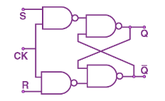

**Truth Table :**

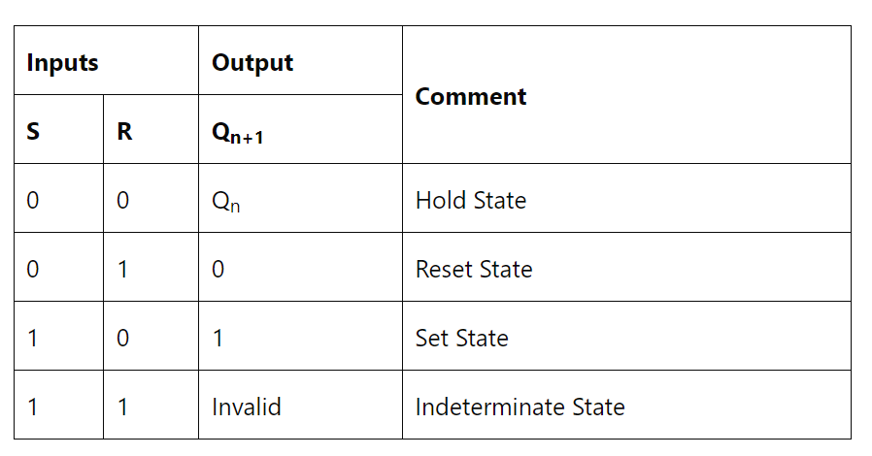

**Excitation table:**

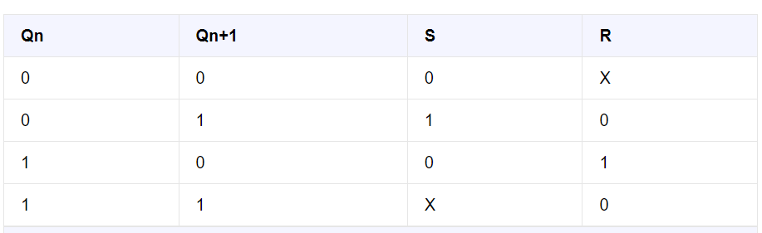

**Characterstic Table:**

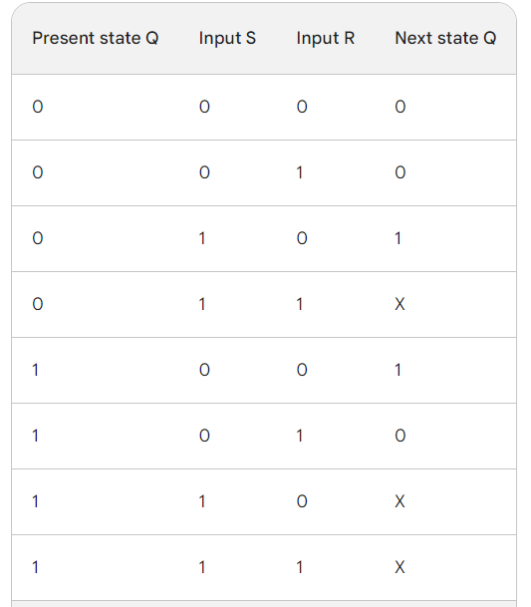

X 🡪 undefined state.

**JK – FLIP FLOP**

**Def:**  A JK flip-flop is a type of digital logic circuit that is widely used in digital electronics for its ability to store binary information. It is an edge-triggered flip-flop that can operate in two modes: the "toggle" mode and the "set/reset" mode. The JK flip-flop has two inputs, J (set) and K (reset), along with a clock input (CLK) and a single output, usually labeled Q.

**CIRCUIT DIAGRAM:**

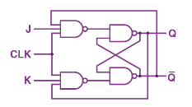

**TRUTH TABLE:**

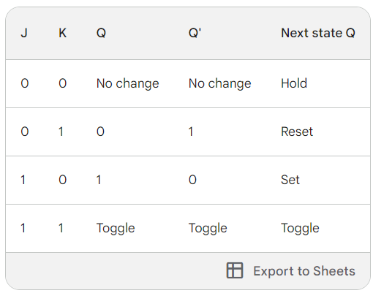

**CHARACTERSTIC TABLE:**

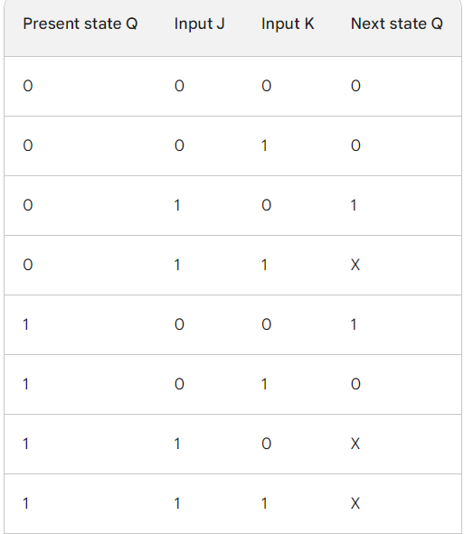

**EXCITATION TABLE**

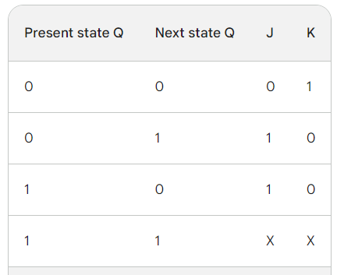

1. **Differences between the Latch and flip-flop**

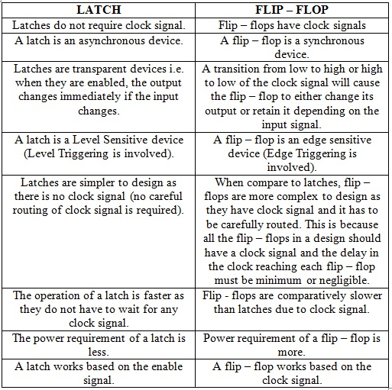

1. **Why latches are faster than Flip-flops ?**

Transparent operation: Latches are transparent, which means that the output of the latch changes immediately when the input changes. Flip-flops, on the other hand, are edge-triggered, which means that they only change state on the rising or falling edge of the clock signal.

Simpler circuit structure: Latches have a simpler circuit structure than flip-flops. This means that latches have fewer transistors and less parasitic capacitance.

Less power consumption: Latches consume less power than flip-flops. This is because latches have a simpler circuit structure and do not need to use a clock signal.

These key points contribute to the overall speed advantage of latches over flip-flops.

In addition to the above points, latches can also be faster than flip-flops because they do not have to wait for the clock signal to propagate through the circuit. In high-speed circuits, the propagation delay of the clock signal can be significant. Latches can avoid this delay by operating independently of the clock signal.

Overall, latches are faster than flip-flops because they are transparent, have a simpler circuit structure, consume less power, and do not have to wait for the clock signal to propagate through the circuit.

However, it is important to note that latches are not as reliable as flip-flops. Latches are more susceptible to noise and glitches. For this reason, latches are typically not used in critical applications.

1. **Explain the use of** 
   1. **Flip flop**

Definition: A flip-flop is a bistable sequential circuit that can store a single bit of data.

Uses:

* To store data

Registers: Flip-flops can be used to implement registers, which are circuits that store data. Registers are used in a variety of applications, such as storing the results of arithmetic operations, storing the current state of a sequential circuit, and storing data that is being communicated between different parts of a circuit.

* To count events

Counters: Flip-flops can be used to implement counters, which are circuits that count events. Counters are used in a variety of applications, such as measuring the frequency of a signal, counting the number of pulses in a train of pulses, and generating timing signals.

* To shift data
* To divide frequencies
* To implement control logic

1. **Why is Gated SR Flip Flop called Asynchronous Latch ?**

A gated SR flip-flop is called an asynchronous latch because it responds to its inputs immediately, regardless of the clock signal. This means that the output of the latch can change at any time, as long as the inputs change. This is in contrast to a synchronous latch, which only responds to its inputs on the rising or falling edge of the clock signal.

The term "asynchronous" means "not synchronized." In the context of digital circuits, it means that the circuit does not rely on a clock signal to control its operation. This makes asynchronous circuits faster than synchronous circuits, but it also makes them more complex and difficult to design.

Gated SR latches are often used in applications where it is important to respond to changes in the inputs as quickly as possible, such as in data communication circuits and control circuits.

1. **Implement D-FF using NAND Gate**

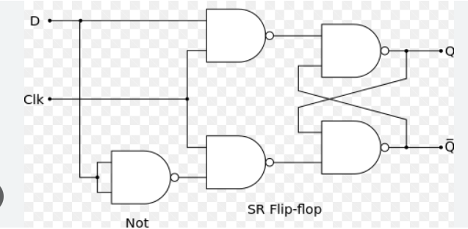

1. **Design D-FF using 2:1 MUX**

